**Group Report**

**Group 14**

1. **Problem definition (10%)**

From completing the first phase being the user research part of the project, the next area we have moved on to is the development of designing a prototype for the mobile app we will create. The app is based on a smart home system which was researched thoroughly from phase 1 of the project.

The purpose of the app is to help the user control various aspects of their home, such as the lights, the temperature, and even security features like cameras to ensure the safety of his family. Prior to the design phase, we did research on how many people would be interested in this product, thereby locating our target demographic. We then based our personas and user stories on this demographic, which in turn, allowed us to design an app that best fits their demands. The key outcomes from our research indicated that our design needed to focus on minimalistic and functional.

The goal of the project is to make using a system like this simple and intuitive. To achieve this, we had to design a prototype for our app, which aided us in meeting the demands of our personas and making an intuitive, aesthetically pleasing app to suit their needs.

1. **Your methods and conceptual designs (35%)**

**User stories/personas-**

We started by creating a Miro board. On this board we took our primary and secondary personas main points/requests from phase 1 and formatted them into boxes that clearly display their main interests. We drew upon these interests when further designing our prototype, as these personas represent our target demographic. Below is an image of our user stories.

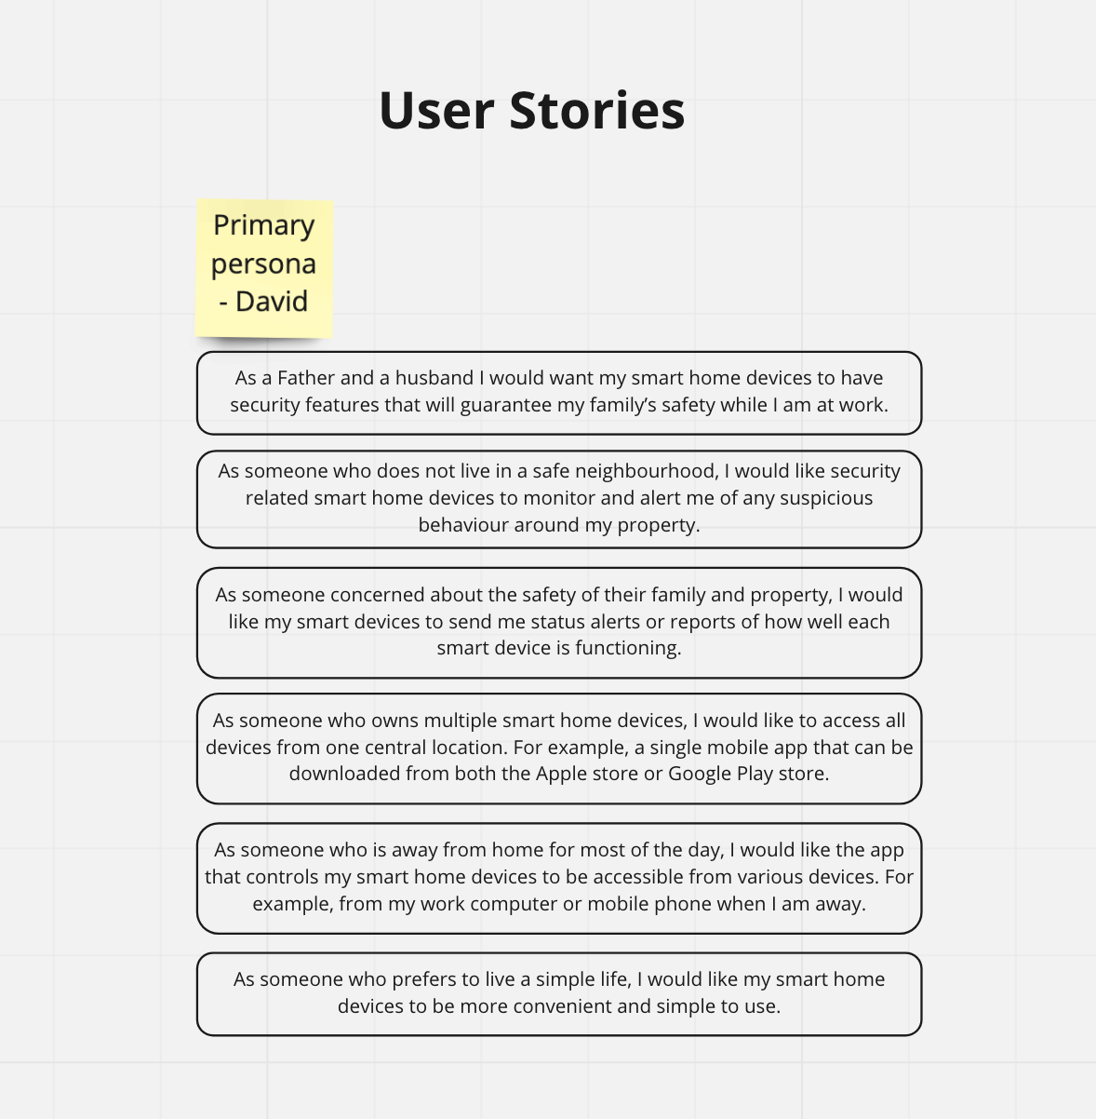

**Requirements, Features and Pages-**

We took our personas interests and turned them into requirements, for example our primary persona, David, values ease-of-use, as such we made this one of our requirements. We then took these requirements and turned them into features. To meet Davids need for simplicity, one of our features is the minimalistic aesthetic and design of the app. It then had to considered how these features could be implemented into our pages. In the case of Davids ‘ease-of-use', we arrived at the conclusion that a simple homepage layout would meet this requirement. This method of planning was used for all our personas needs. Another example is David prefers to have all his smart devices in one location so, we have made sure that all smart home devices is in one application, to meet Davids requirements of Mutiple smart devices on one central location. Below is an image of our Requirements, features, and Pages.

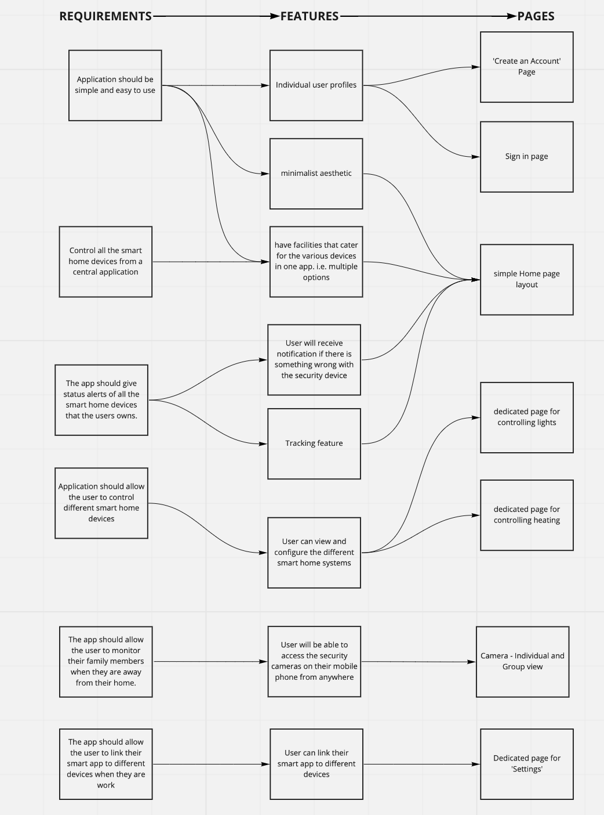

**Navigational model/site map-**

This model serves the purpose of helping us to navigate between pages, it aids us in visualising the layout, and making the system as easy-to-use as possible. For example, it helps us to see which buttons lead to which pages, as well as what content these respective pages contain. It provides us a complete picture of the design, allowing us to get rid of any unnecessary pages and identifying the unique features and functions that each page will have. The sitemap will also help us identify if the pages are user friendly. Below is an image of our site map that we created based on the user requirements from phase 1.

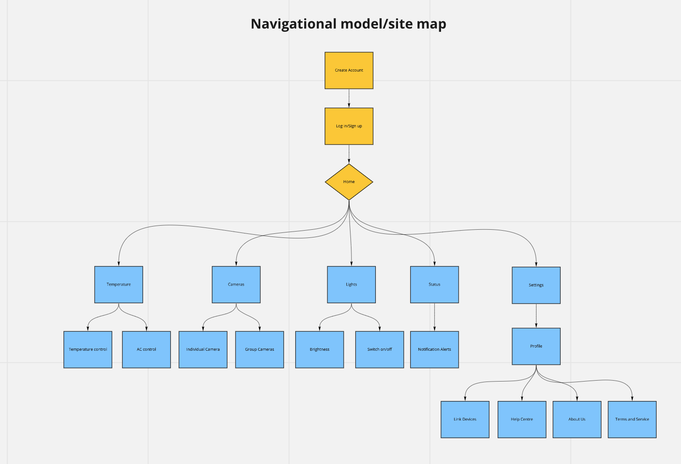

**Low fidelity prototype-**

Our low fidelity prototype was our first concept of what our design for this system might be. It gave us insight into what designs would be functional as well as aesthetically pleasing. To create the low-fidelity prototype, we made use of the ‘Design Thinking’ model to identify all the requirements of our user. We completed this prototype using the wireframe tools on our Miro board, this is important as it was useful for us because it gave a flexible approach, should anything need to be changed immediately or even in later stages. Below is an image of our low fidelity prototype.

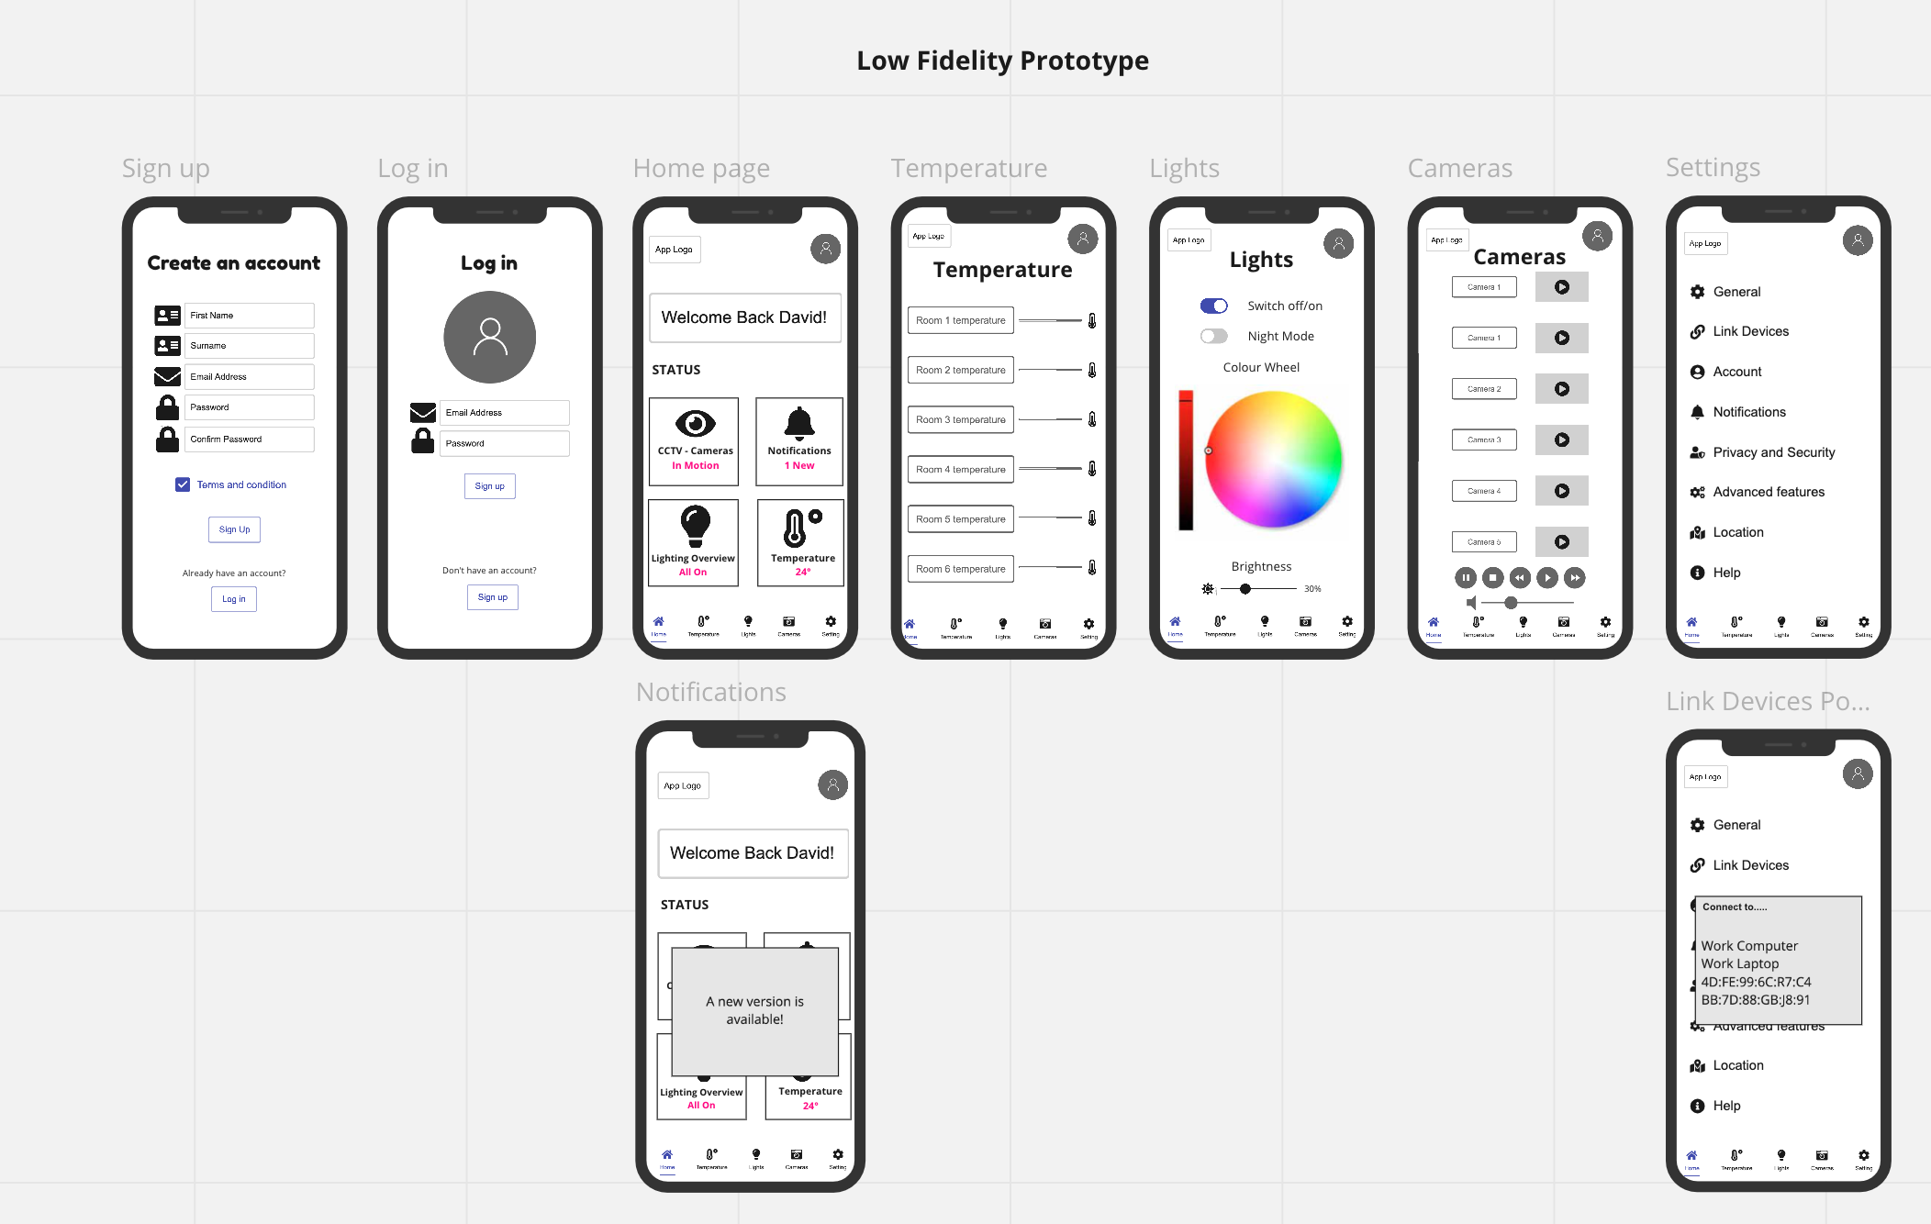

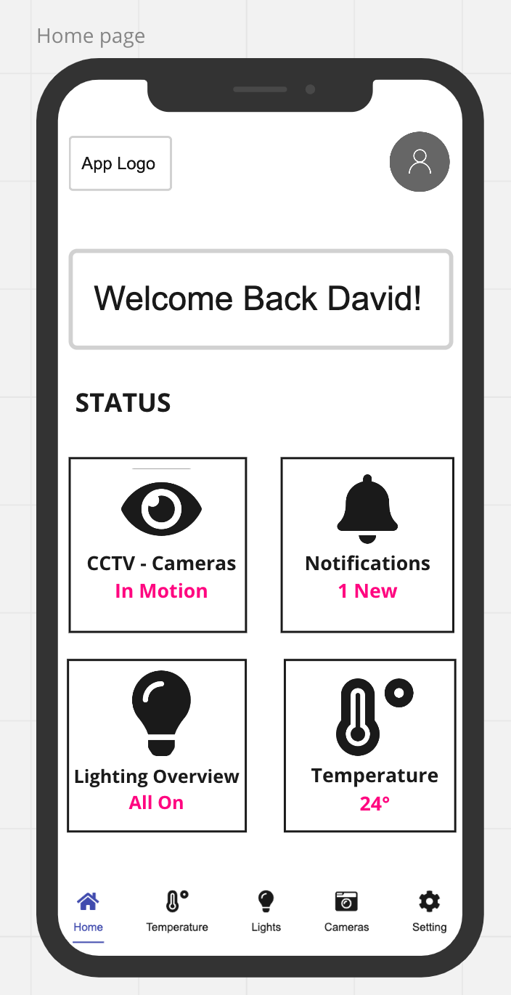

The above image displays a ‘bottom bar menu’ that we created for each page of our smart home app. We were influenced to create this, while we were researching for UI design patterns for mobile app navigation. The ‘bottom bar menu’ comprises of hotkeys that are located at the foot of the app. It allows the user to easily navigate through the various pages of the smart home app.

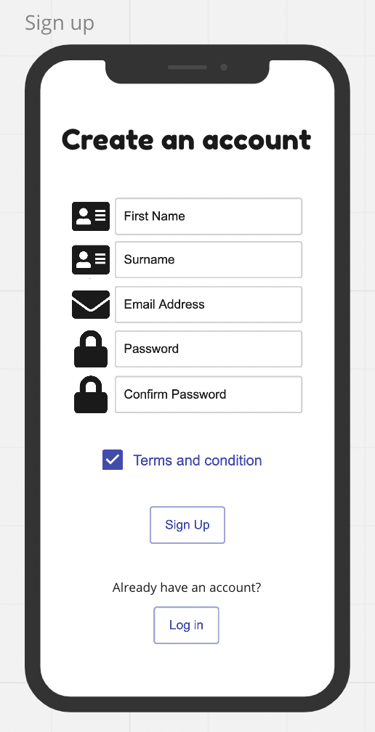

This another page taken from the low fidelity prototype we have intended creating the sign-up page with using the second guideline from Nielson and Molich’s UI design guideline. This rule of thumb is to “match between systems and the real world” inspired us to use icons that similarly match real world conventions such as the email icon highlighting the user to be able to type their email address. The user finding it easy to operate on the app can be possible through minimalizing any clutter and unnecessary information.

**Wire flow chart-**

The image below, displays our wire flow chart. The purpose of this is to show the user workflow and the interaction with the different pages. The wire flow that we have created will exhibit the various steps a user will go through to complete the task. While the initial pages have less interaction between them, the main sections enable the user to freely navigate each individual page with the addition of buttons and widgets. Below is an image of our wire flow chart.

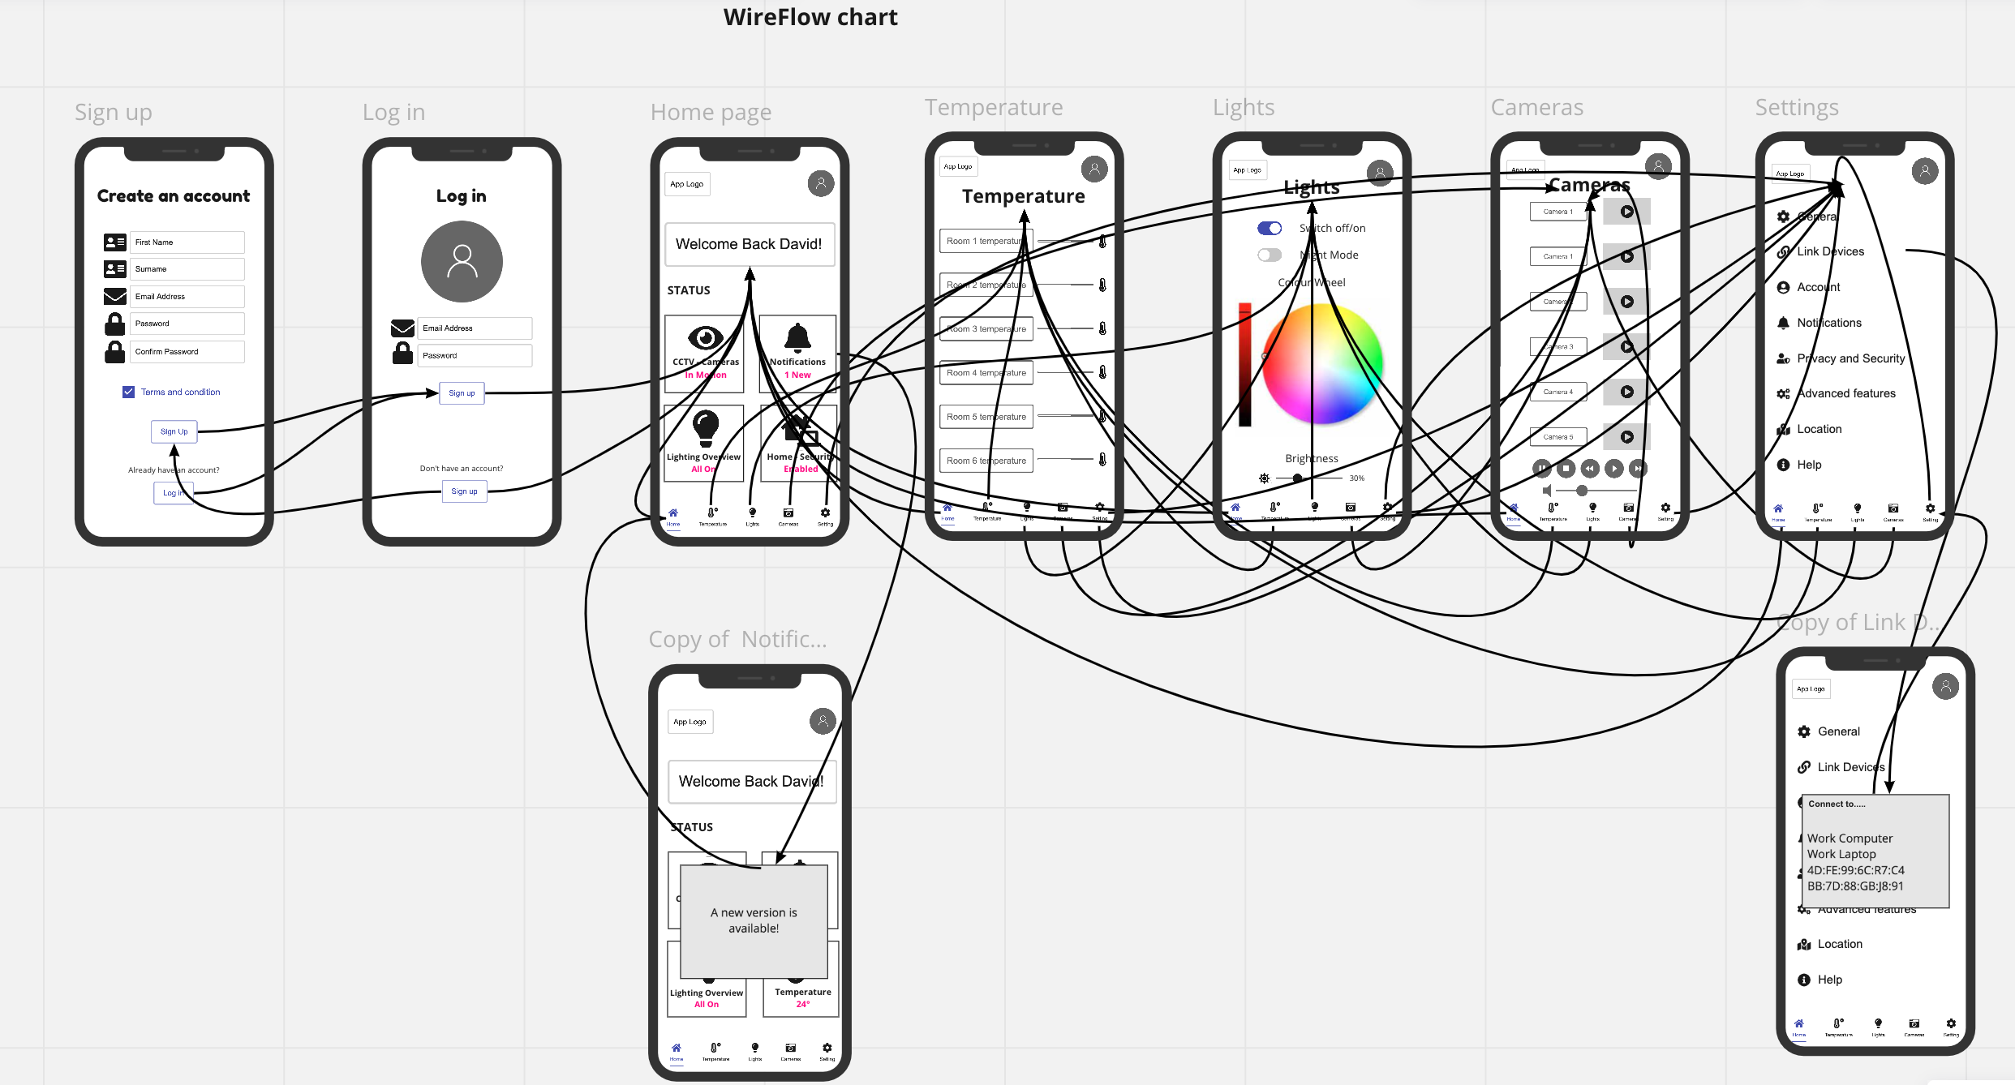

**Storylines-**

Below is an image of the storylines we created for each page of our smart home app. Storylines helped us to understand and prioritize the main feature requirements of our persona 1, David. For the storylines we talked about the main goal, design strategy and storyline for each page of the smart home app that we designed. 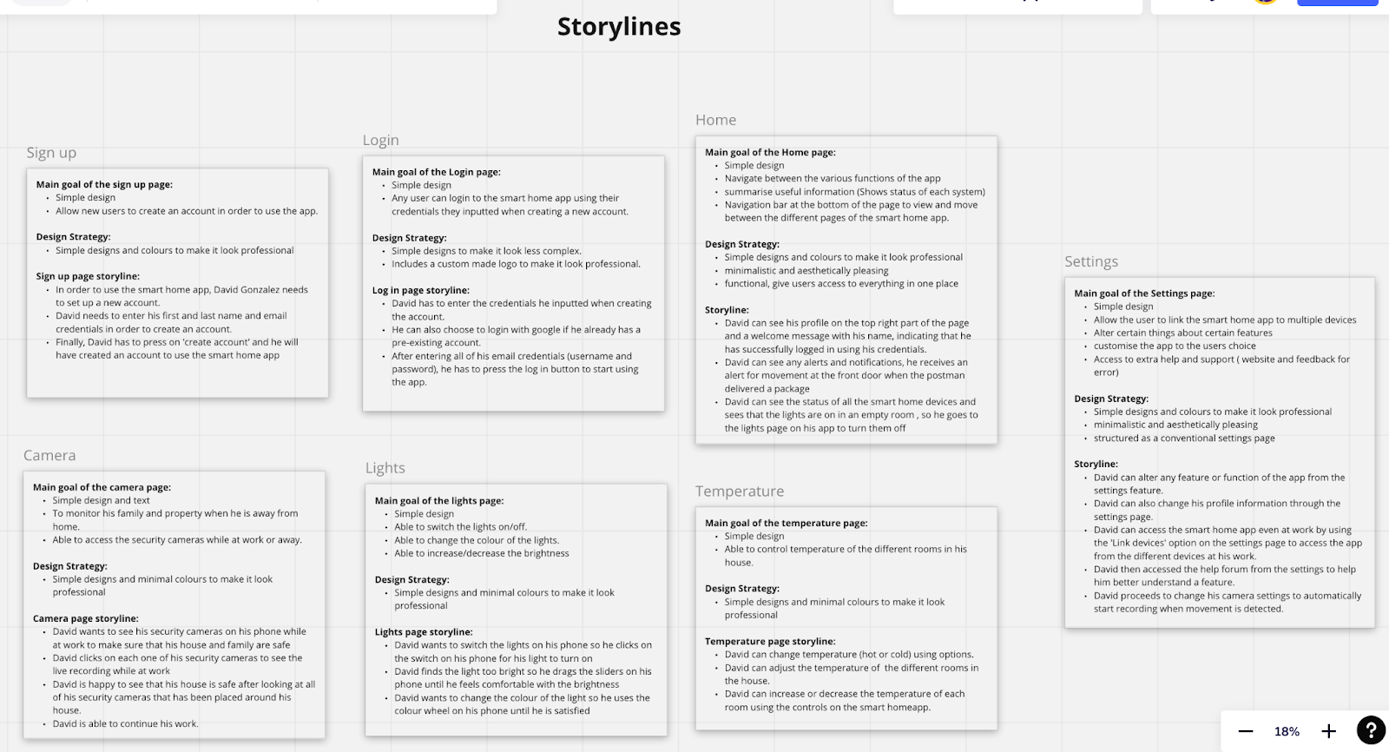

**High Fidelity Prototype-**

The image below, displays the different pages of our smart home app that we created in Figma according to all the user requirements of persona 1. We were influenced by Don Normans principle of ‘Consistency,’ so we made sure that all the pages of our smart home app will have consistent colour, layout, capitalization, and fonts. Doing this will also ensure that our smart home app will look professional and aesthetically pleasing.

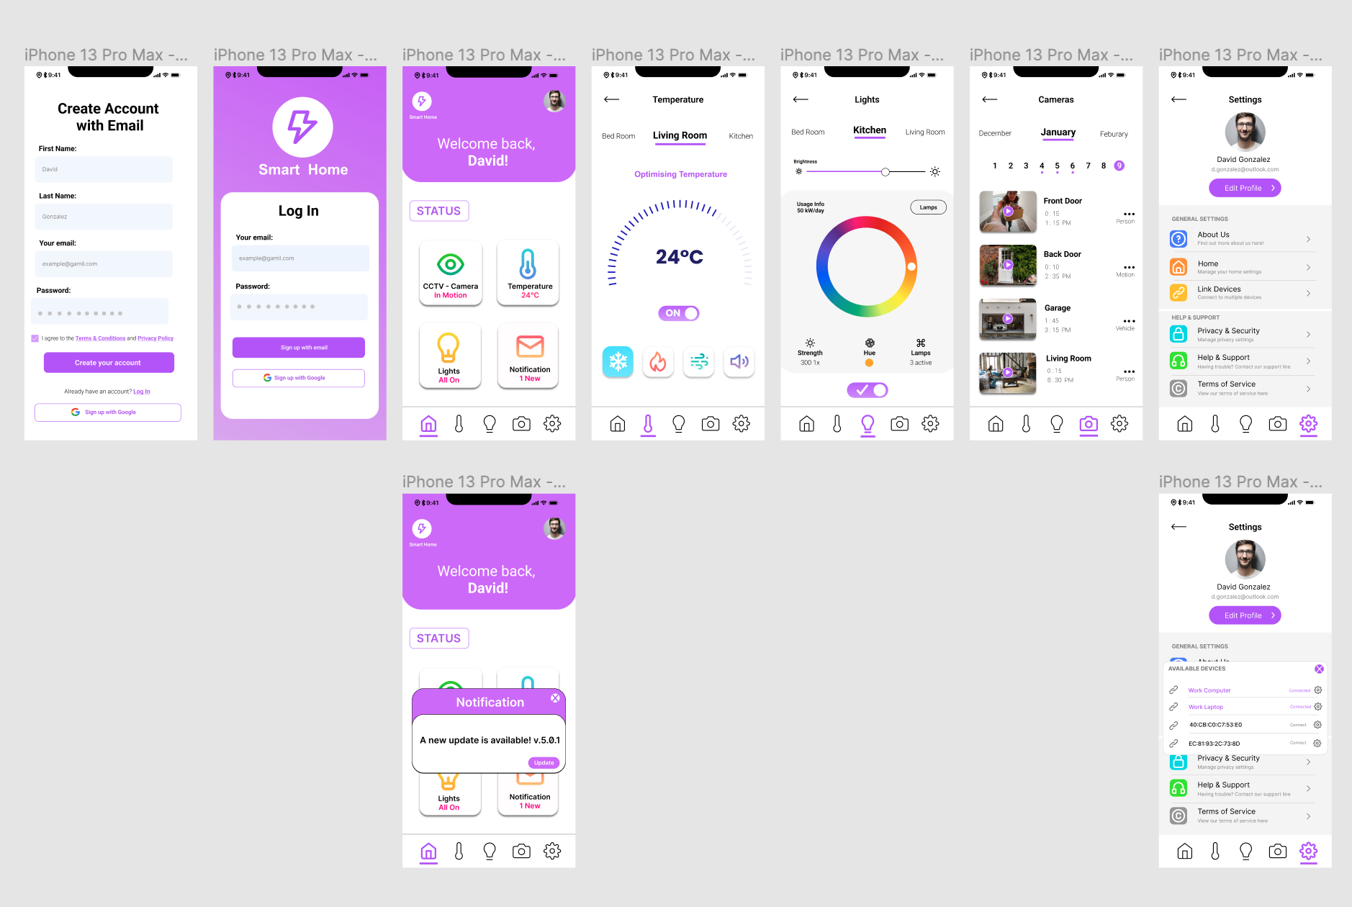

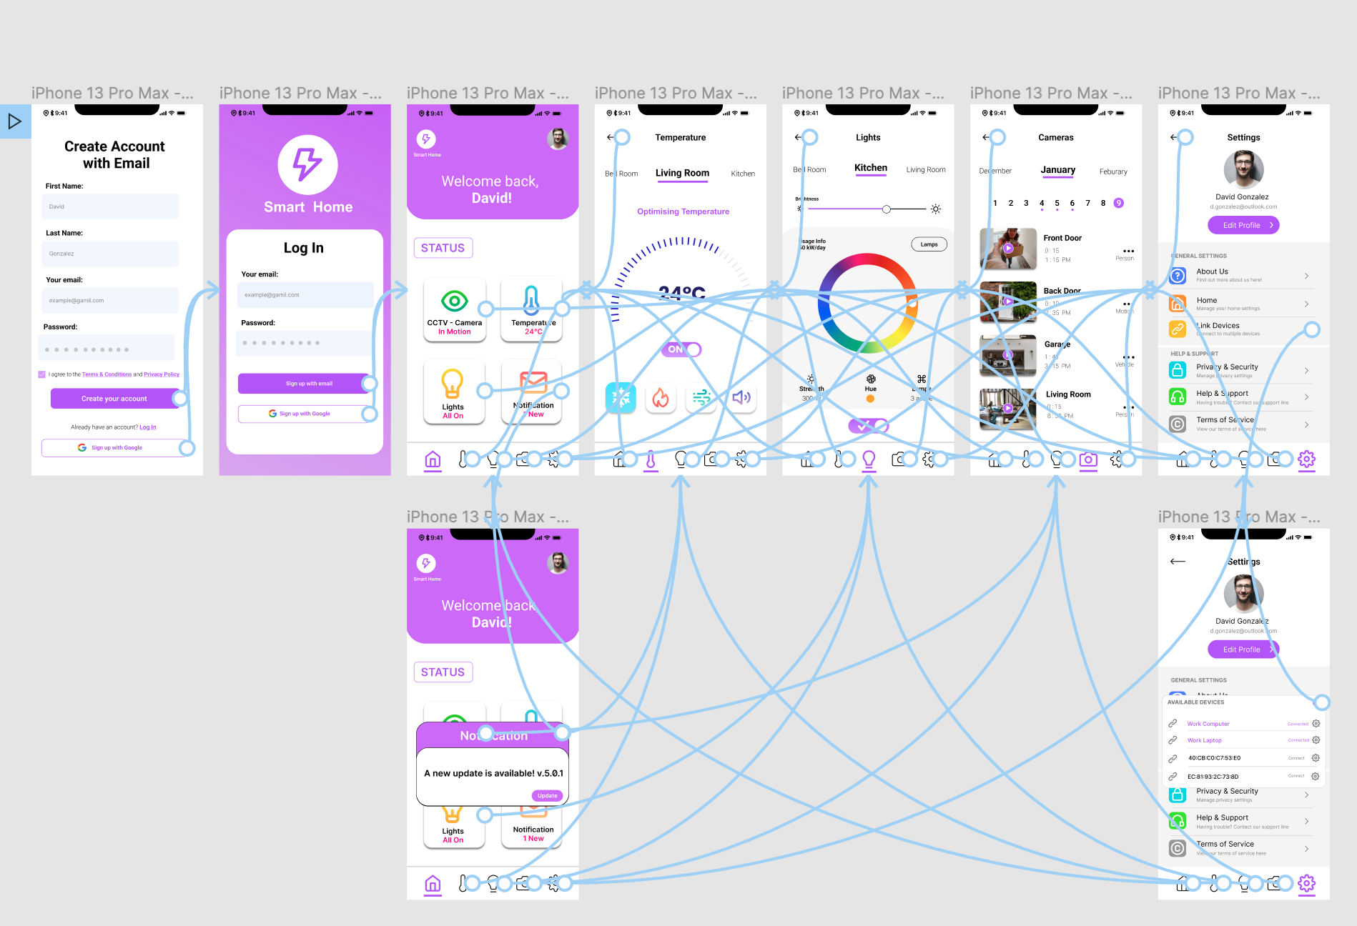

The above image displays that we have created all the prototyping, making our smart home app more interactive and allowing the users to easily navigate through the various pages of the app.

**Group Discussions-**

To effectively carry out and complete the phase 2 of the UX module, our group had to make use of two Common Ground theories of Communication by Clark and Brennan's ‘Audibility’ and ‘Reviewability’. For example, in terms of ‘Audibility,’ my group used zoom meetings to discuss and review all the work we have done weekly. In terms of ‘Reviewability,’ my group have used WhatsApp text messages to enquire about specific tasks that we needed more help with. Throughout phase 2 we have communicated through WhatsApp or through zoom meetings, doing this has allowed us to produce innovative designs ideas and improve on our work even further. Below are some screenshots of our UX design WhatsApp group and it shows an example of how we discuss and help each other to complete a certain task.

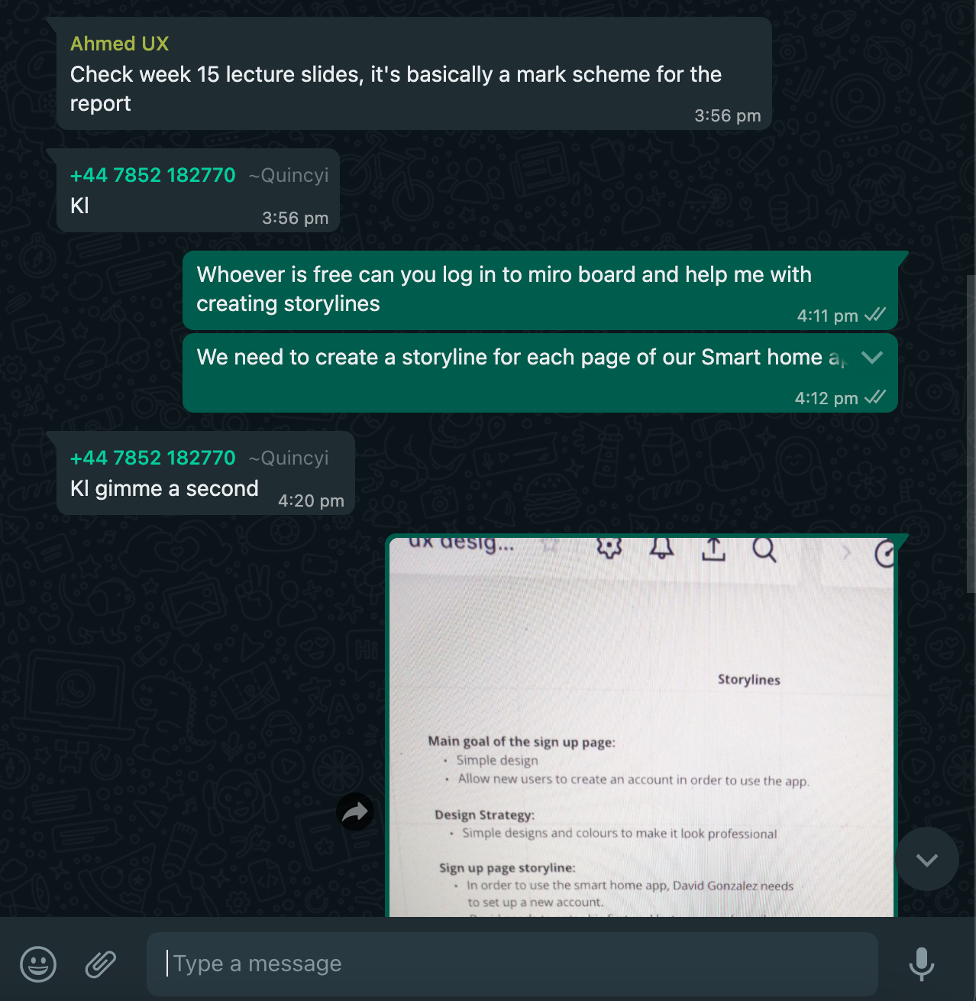

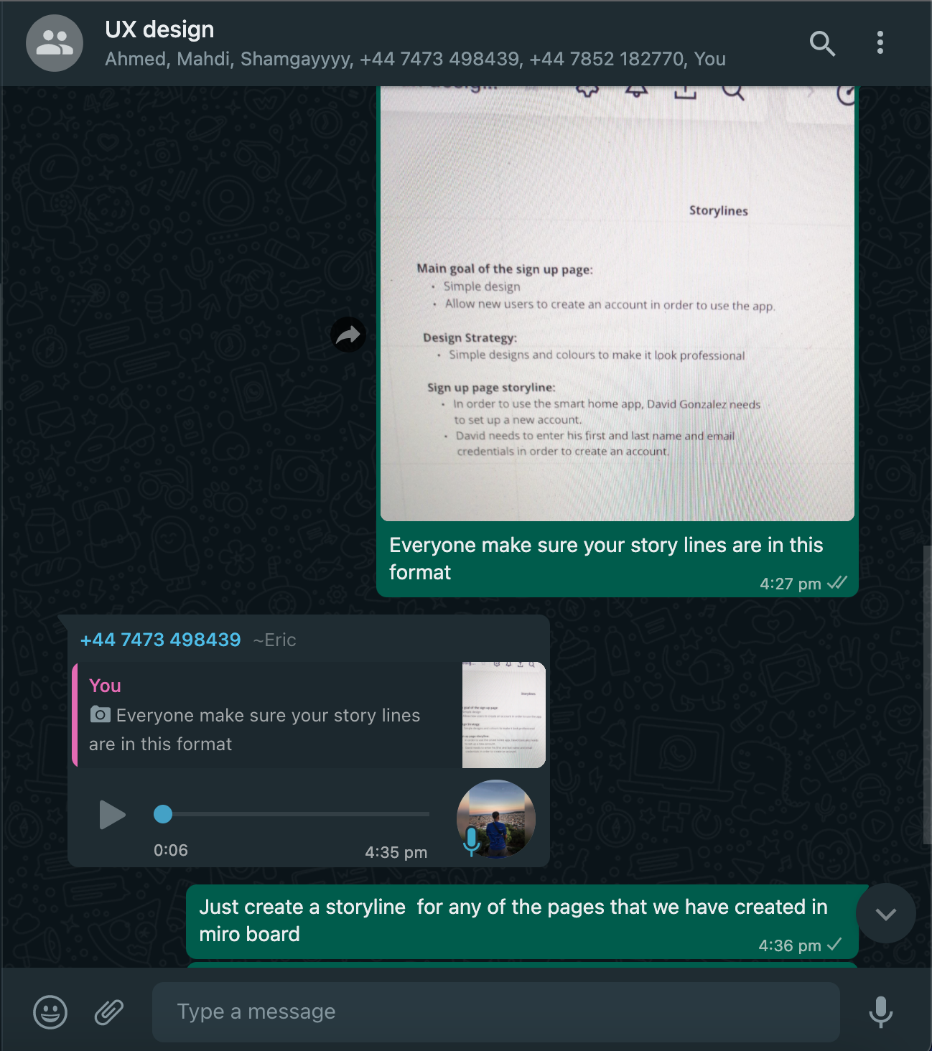  
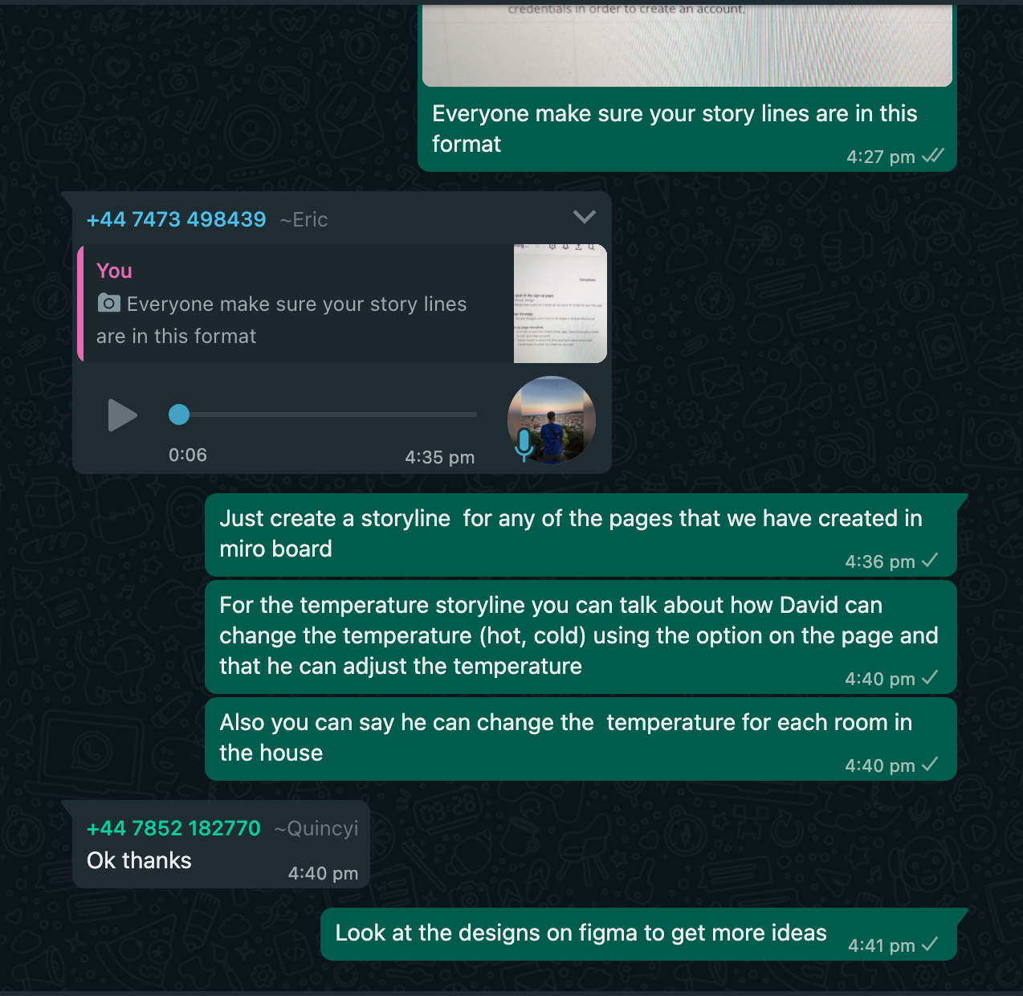

1. **Detailed mock-ups (screen shots and with description) (30%)**

**Create Account Page:**

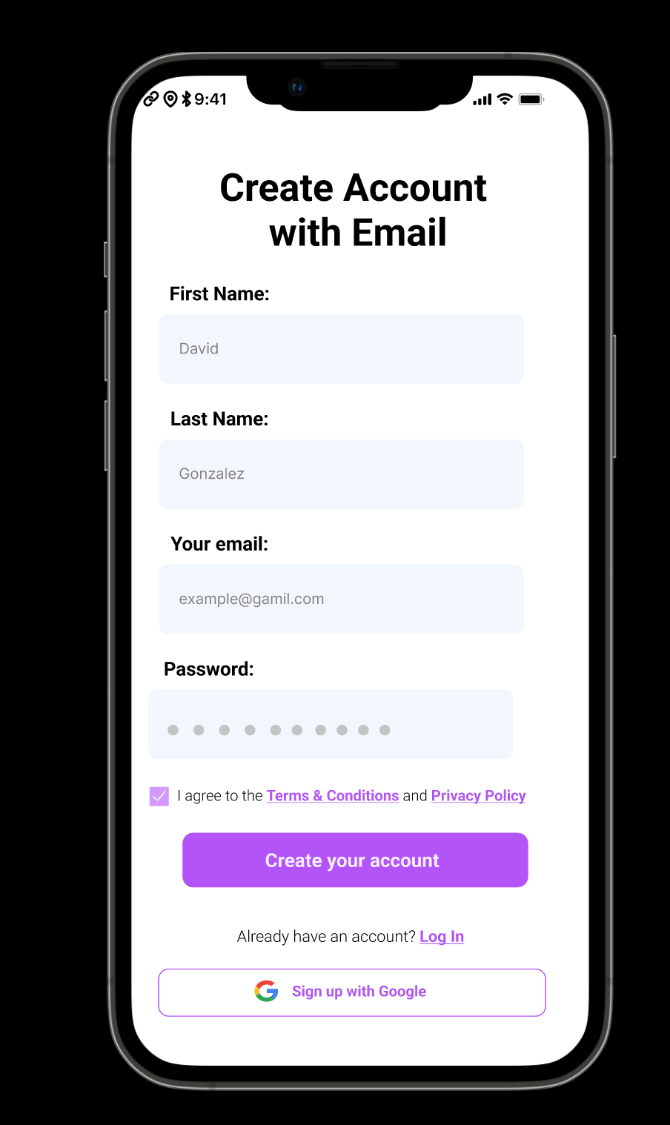

The above image displays the ‘Create Account’ page. This page allows the user to create an account to access the smart home app. The user can add their name and email credentials to create the account. We also have a included an option to sign in with Google if the user already has a pre-existing account.

**Log In Page:**

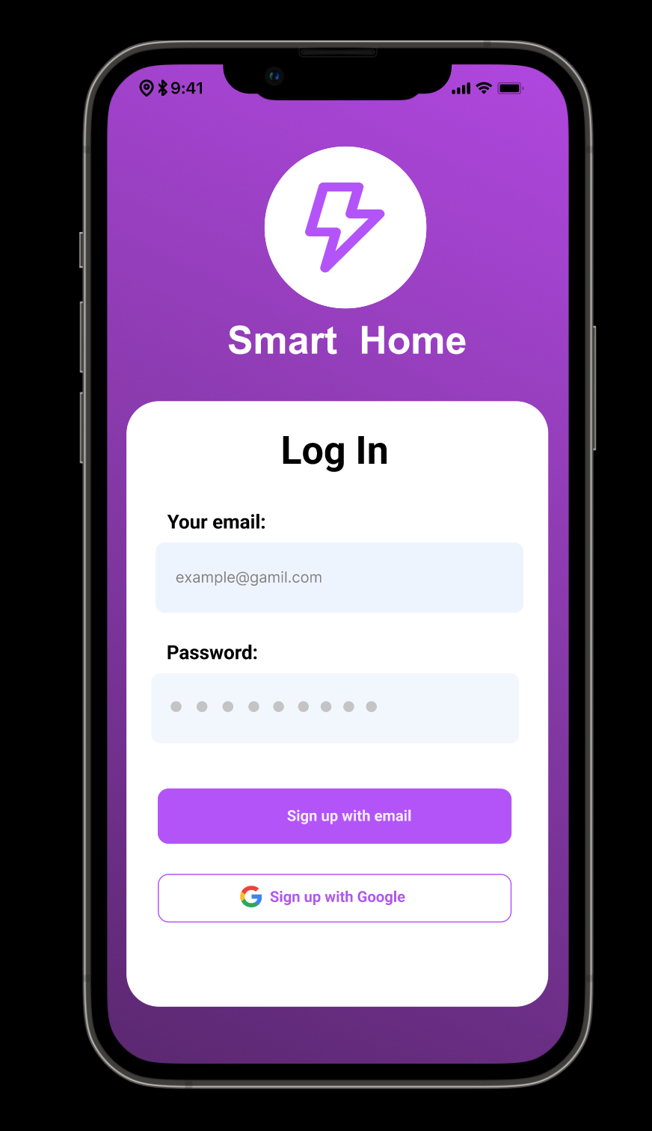

After creating an account, the user can then use their credentials (username and password) to log in to the smart home app. We have also an option to log in with Google if the user already has a pre-existing Google account. We have also created a custom logo for the smart home app that we designed.

**Home Page:**

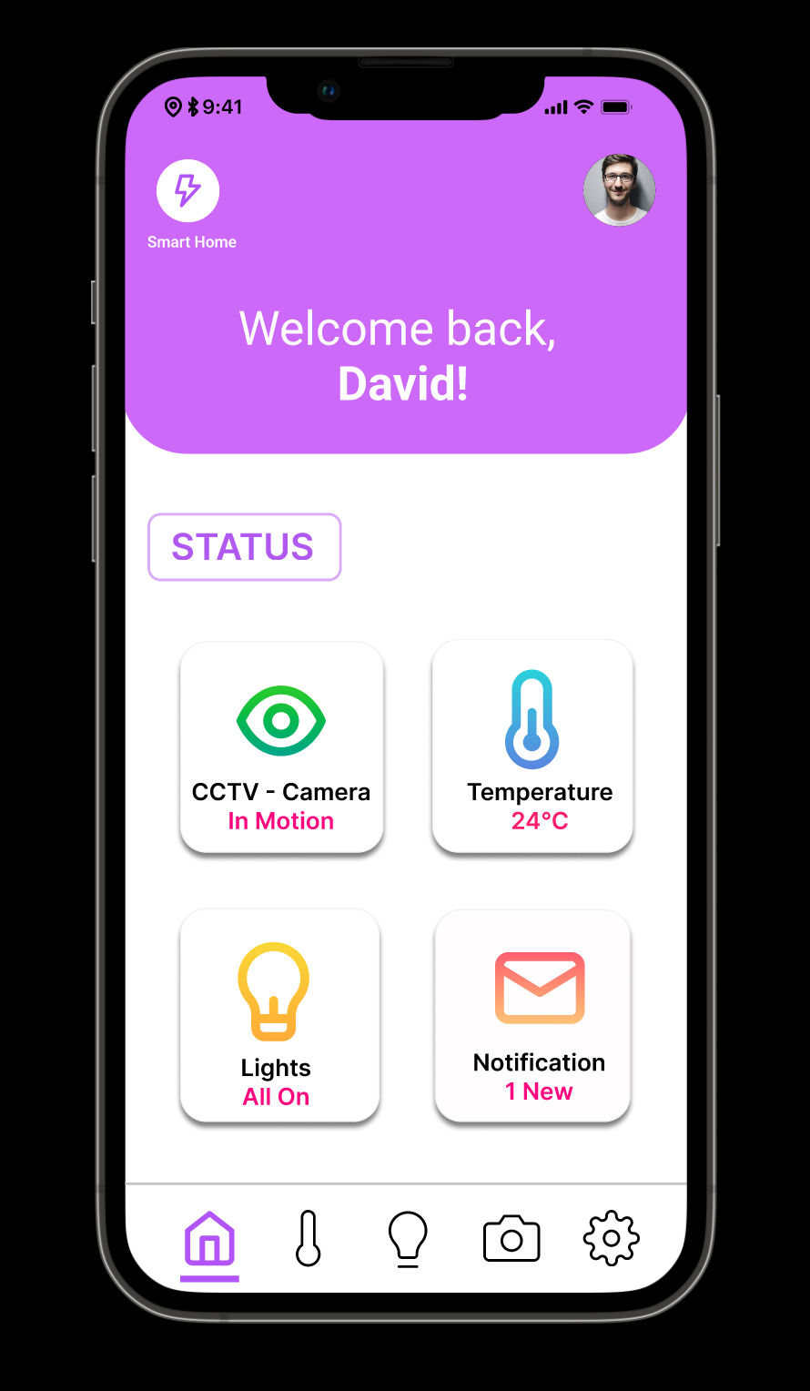

Once the user has entered their credentials and logged in to the app, they will be first presented with the home page. The user requested that the app was simple and easy to use, so we made sure that our home page was designed with a minimalistic and user-friendly approach. After being prompted with a welcome message, the user will be able to identify whether they have successfully logged in or not, by reviewing the picture positioned within the top right corner. Another requirement that the user had was to view the performance status of all the devices in their home, we have designed a status section on the home page allowing the user to view how each of their devices is performing on a single page.

We also used one of Don Normans Design Guidelines called ‘Visibility.’ For example, we added a navigation bar at the bottom of every page of the app, allowing the user to easily view all the different options available and navigate through the different pages of the smart home app. We have designed and created a total of five pages for our smart home app. For example, we have pages for home, Temperature, Lights, Cameras, and Settings.

**Notification Pop-up:**

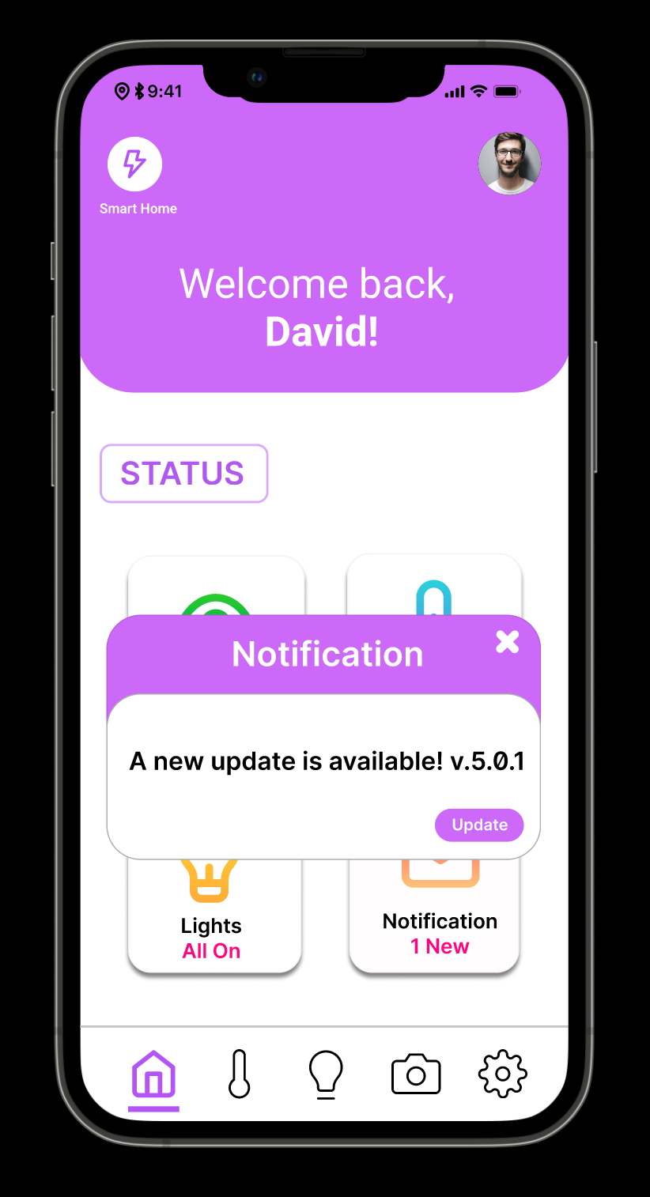

Another requirement that our user had was to view any notifications that he received from both the smart home app and the smart devices connected to it. So, we created a notification pop-up page that allows the user to easily view any notifications they have received. Alerts allow the user to be kept updated about any improvements and changes we as the designers have made to the app, so that important is communicated effectively and is received as it is in the user’s face.

**Temperature Page:**

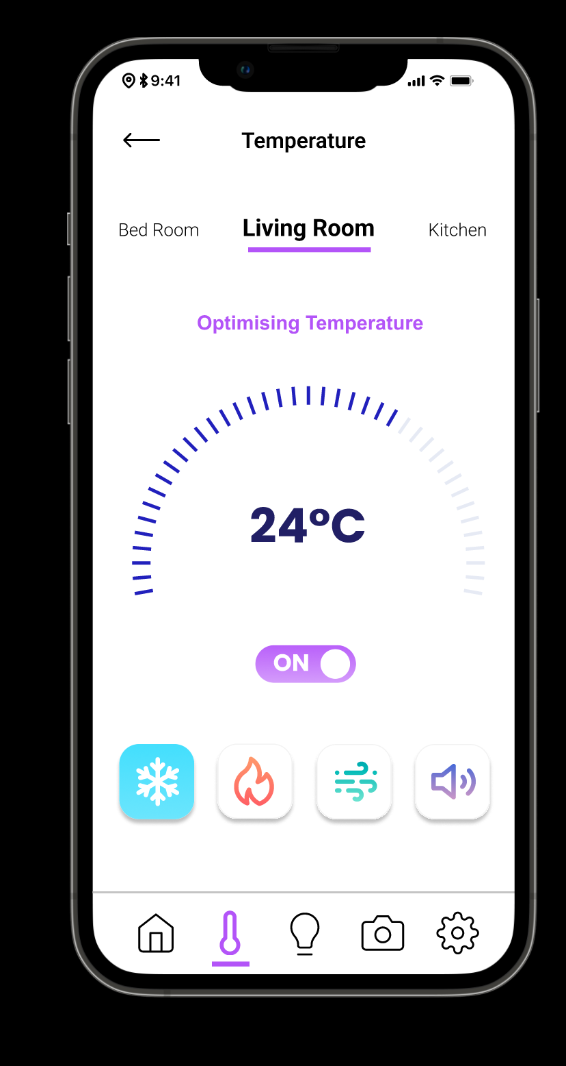

Another requirement that the user has was to control and adjust the different smart devices that he had connected to his home. So, we created a dedicated temperature page that allows the user to control the temperature of the different rooms in his house. The user can also view the current temperature of each room and can cool or heat the rooms according to his needs.

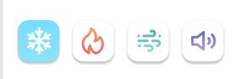

From the above image we have given easy buttons where the user at ease can toggle from raising the temperature for a particular room or can decrease the warmth of the room with the 1st button. Again, here we have used conventions that make its use easy and simple to operate when using it.

**Lights page:**

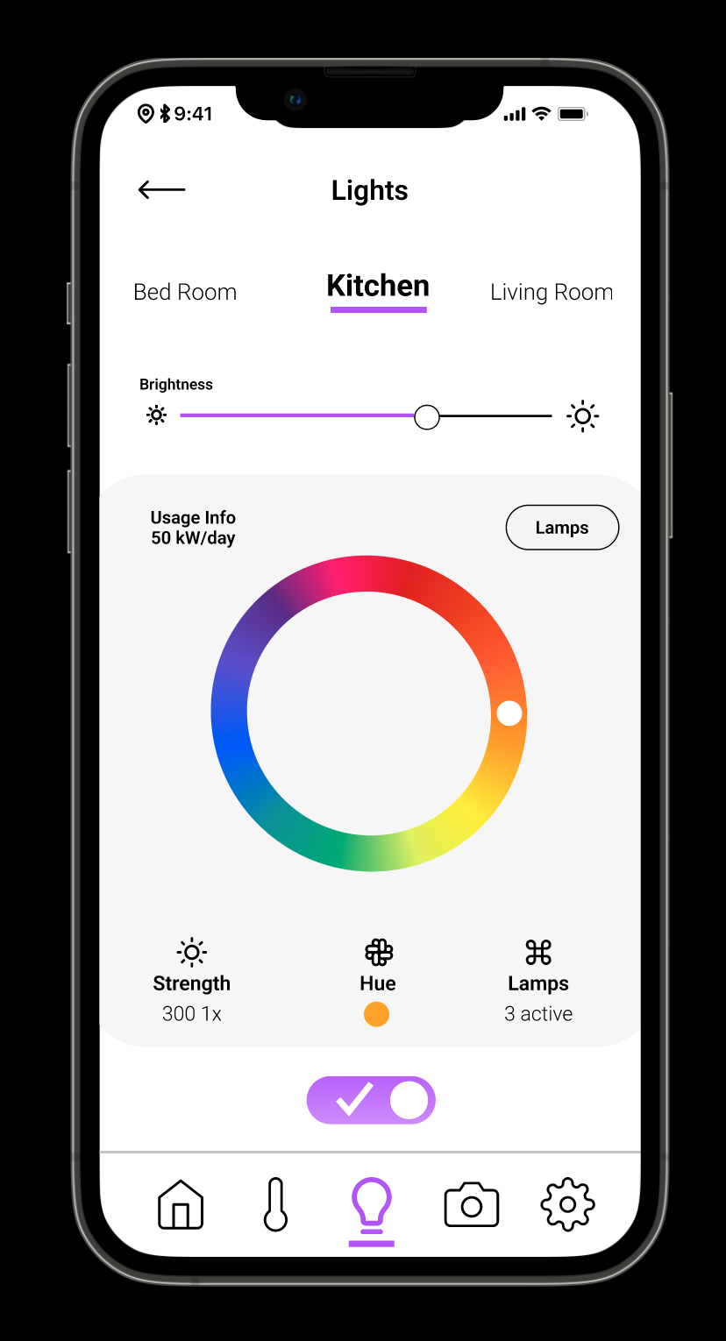

Another requirement that the user has was to control and adjust the different smart devices that he had connected to his home. So, we created a dedicated Lights page that allows the user to control the brightness and the colour of the lights for each room in his house. The user can easily change the colour of the lights using the colour circle and adjust the brightness according to their needs.

**Cameras Page:**

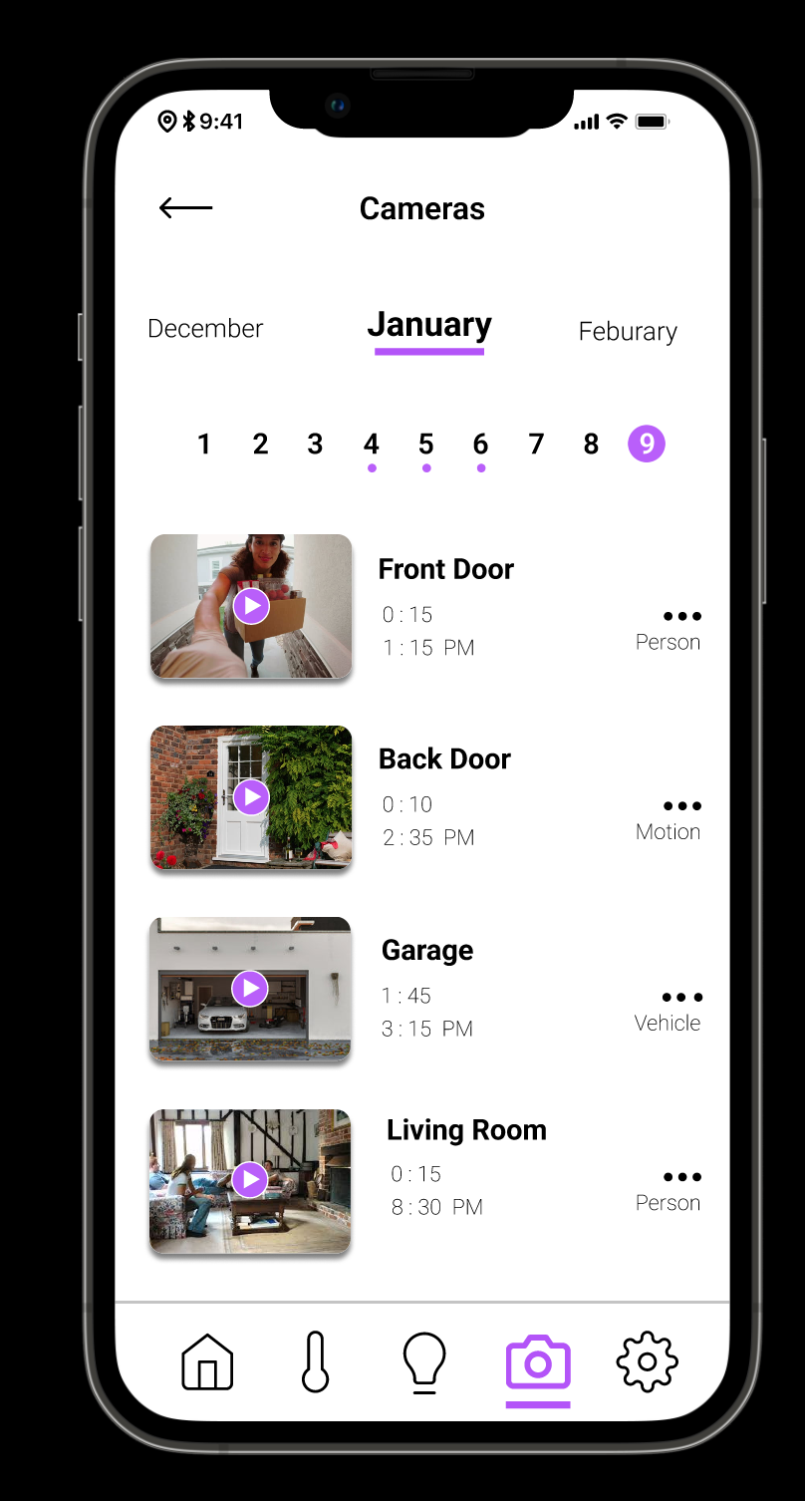

Another requirement of our client was to monitor their family while they are at work. Therefore, we created a dedicated camera section that would allow our client to monitor and guarantee the safety and security of his family while they are at work. Our smart home app allows the user to view videos that cameras recordings from different dates. The cameras also send an alert to the user if it has noticed any suspicious behaviour around the user's property.

**Settings page:**

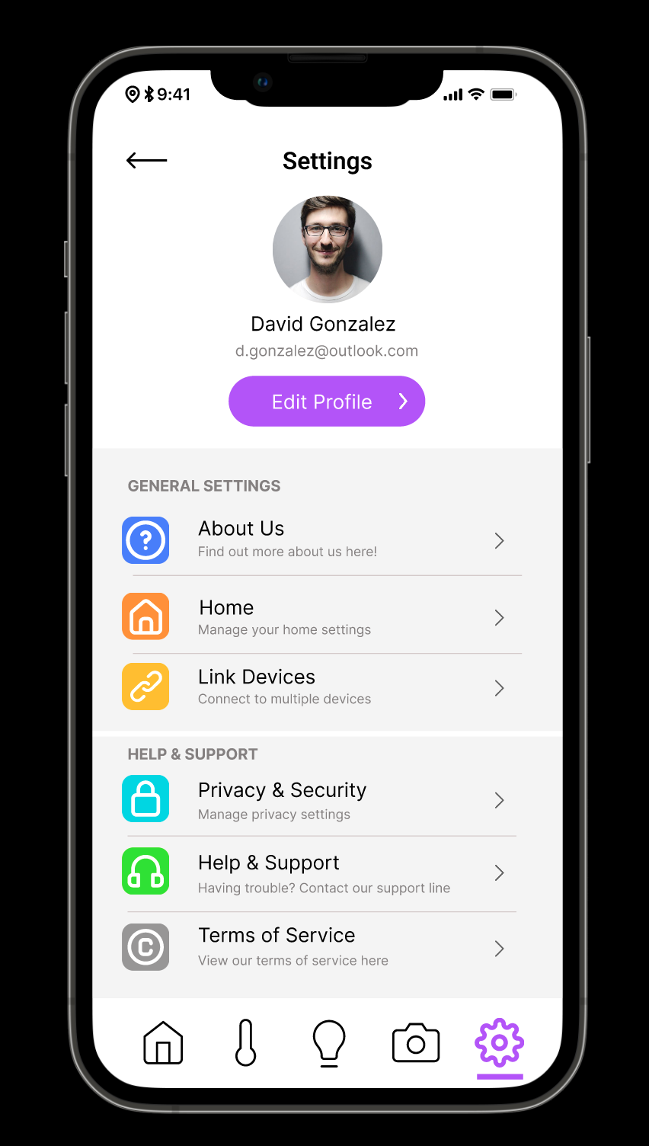

Above is an image of the settings page of our smart home app, the settings page allows the user to control various aspects of both their profile and the smart home devices.

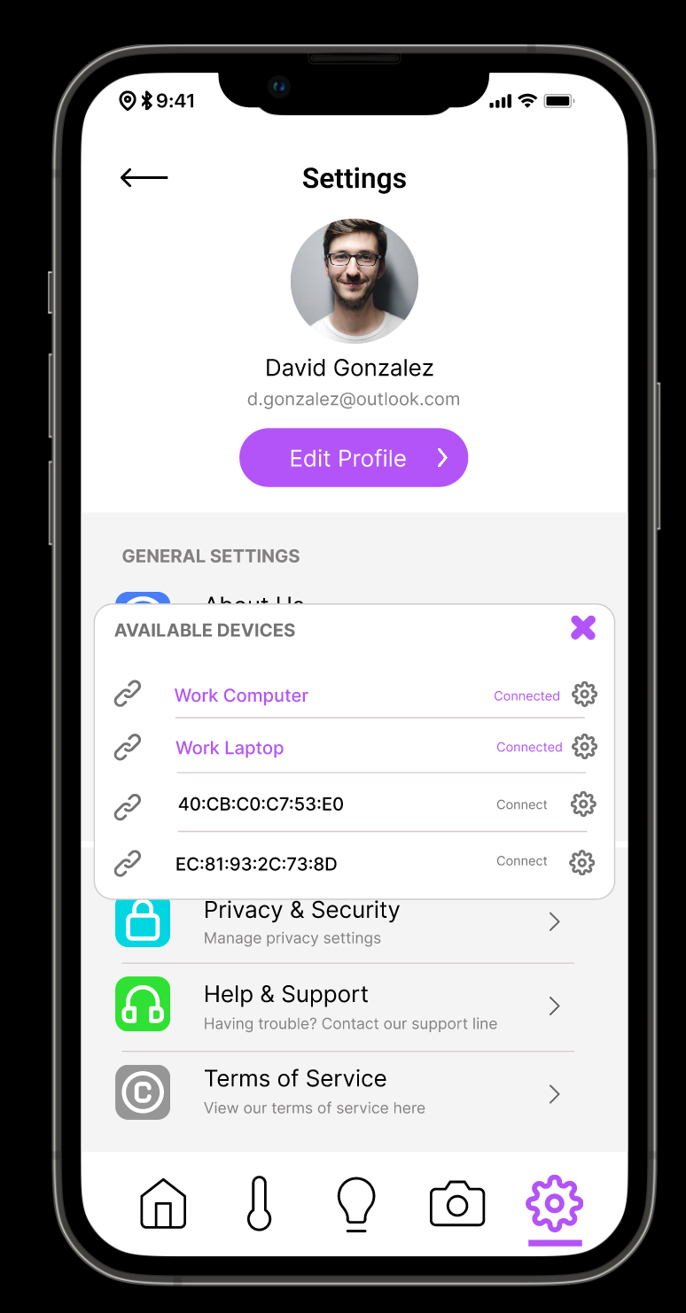

The final requirement that our user had was that they wanted the smart app to have a feature that allowed them to link the smart app to other devices. For example, since the user works away from home and sometimes goes on business trips, he would like to link the smart home app to his work computer and laptop. As can be seen in the above image, we have included a ‘link devices’ option in the settings menu. Once the user clicks on that option, they will be able to easily link the smart home app to different devices.

1. **Discussion on what went well and how you would improve your work (20%)**

The development of the smart home app in Figma went well. We had to go through several processes for this to go well. Firstly, we had to identify our user requirements from phase 1. We then created the ‘Requirements, features and Pages’ table, this allowed us to identify the various pages for our smart home app. Next, we created a Site Map, it helped us plan for usability. It allowed us to identify the unique features and functions that each page will have. We then created the low-fidelity prototype, it helped us in visualizing unique design options. Finally, we created a wire flow, it allowed us to understand the user workflow and interactions with different pages. By carrying out these various processes we were able to successfully create an effective and interactive smart home app in Figma.

However, we could have improved our work by speeding up the prototype connections, which can be accomplished by utilising the 'master' components. For instance, if I am working on a screen that has persistent navigation, such as a tab bar. Each menu item must be associated with a certain frame, such as the 'Home' button, which must be associated with the home frame. When a menu appears on several pages, as tab bars sometimes do, the repetitious process of linking may take longer than it needs to.

There is a quicker approach, which begins with the creation of a new master component that contains the instance from the library. You may still link multiple menu items from the instance without it disconnecting from the master because Figma allows us to "deep select down into the nested layers within each component." Some of these repeating components are usually placed off to the side, outside of our prototypes, as a convenient location to access them and maintain the necessary links to various pages.

**Appendix:**

**Figma Certificates of group 14 members-**

**Joseph Dias:**



**Shamraiz Nawaz:**

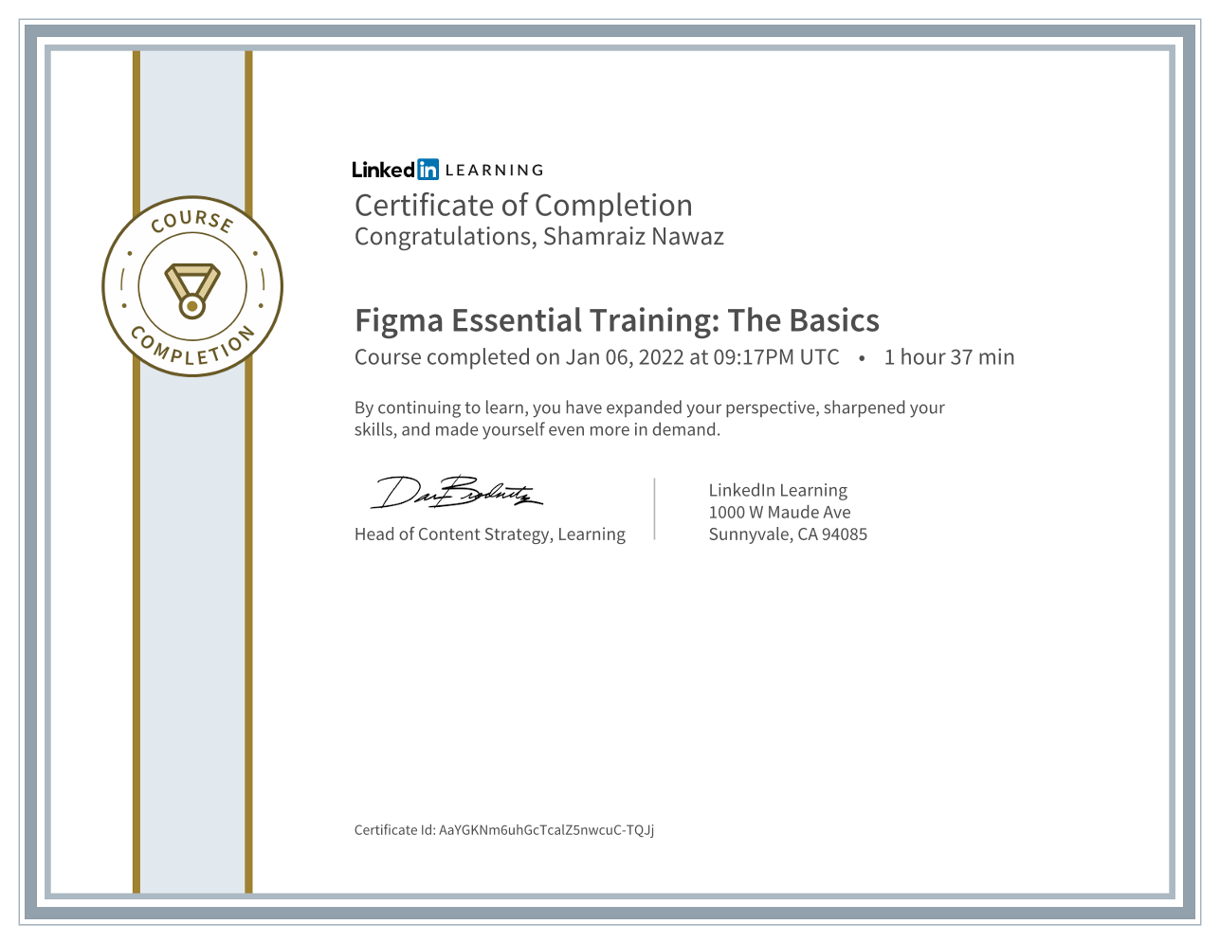

**Ahmed Choudhry:**

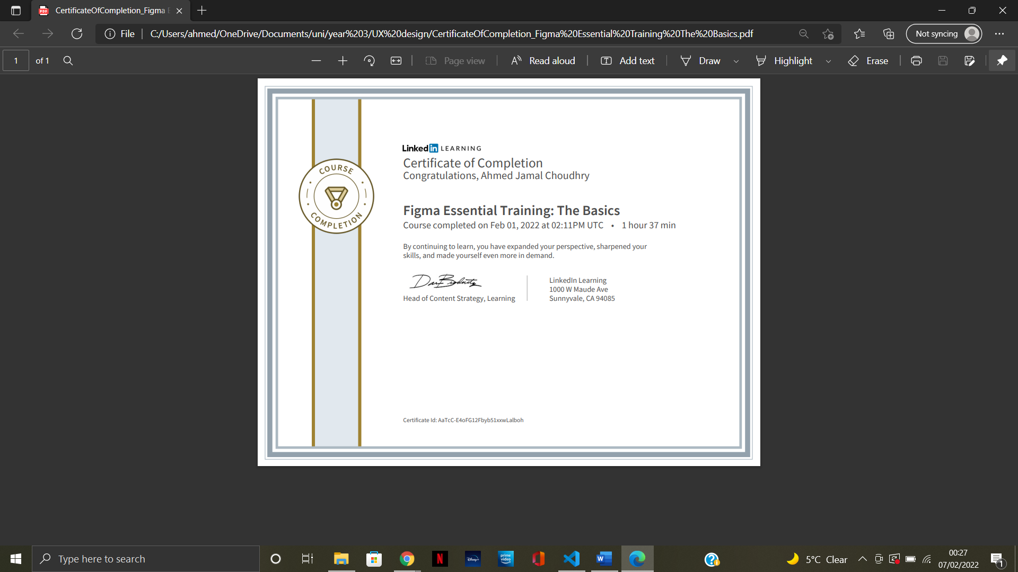

**Quincy Boakye-Lartey:**

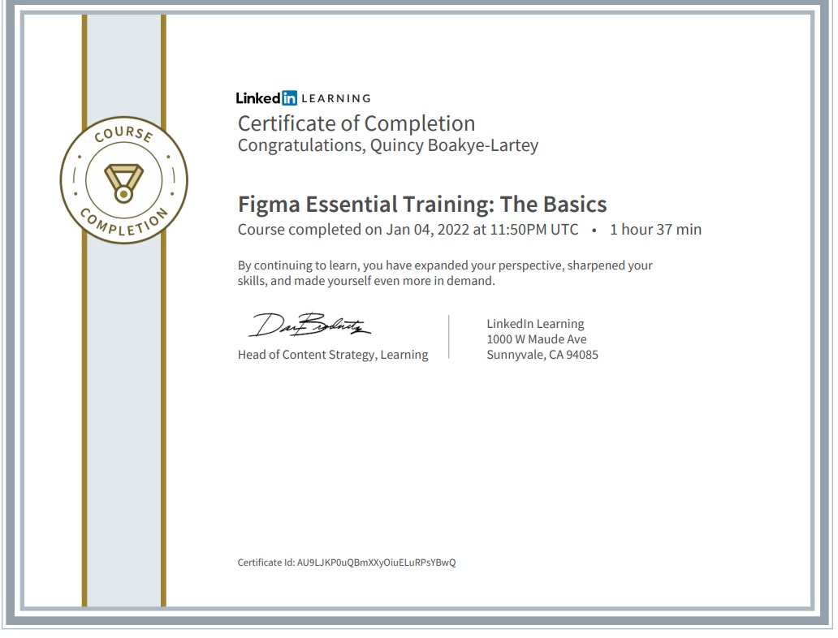

**Mahdi Ahbab:**



**Mohamed Matan:**



Link to our Figma prototype:

<https://www.figma.com/file/bbUvuEGXoYNrPaWfIum4CH/UX-design-prototype?node-id=0%3A1>

Link to our Miro board:

<https://miro.com/welcomeonboard/Mk9MRjhwUHVmUllzQWtLcE9RUWgyaGp3Z0dUVWkyenpqc1NVQkZhRU9hUUJaNXdPSktmZHp0d3M0QjlibXNLY3wzNDU4NzY0NTE2MzYwNjA5NjE3?invite_link_id=218541714790>